HABITS OF A MULTIPLYING DISCIPLE: ENGAGE

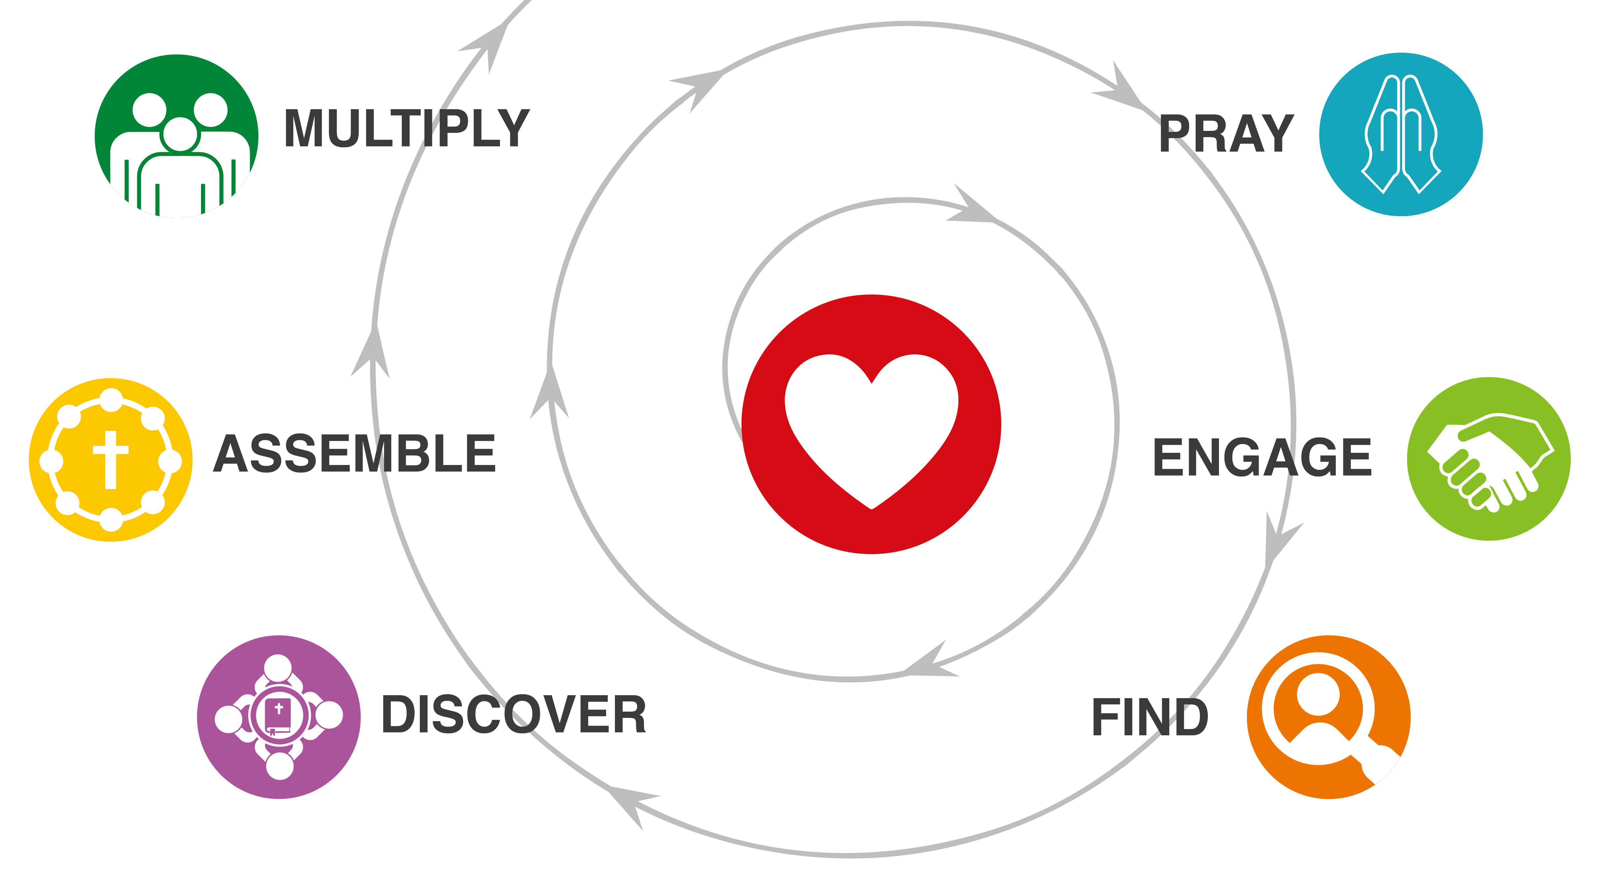
QUICK REVIEW
What are some key things we have learned so far about making disciple makers?

Do you a have a recent story or experience to share related to learning and practicing the habits of disciple makers?

HOMEWORK DISCUSSION
- How did it go adding “extra” to your ordinary prayer?
- How did it go praying for 3 people?

WHAT DOES THE BIBLE TEACH US ABOUT LIVING OUT LOUD?
Read Deuteronomy 6:4-9. Then have one person share their paraphrase of the passage.
- What stood out to you from this passage?
- Can this be applied to our “spiritual children”? How?
- What is the significance of, “Tie them as symbols on your hands and bind them on your foreheads”? Who sees things that are tied to your hands? Who sees things that are tied to your forehead?
- What does it mean to “Write them on the doorframes and gates”? What is the difference between those two places? Who sees these two places?

WHERE IS THERE POVERTY NEAR YOU?
Read Luke 4:18 and Matthew 25:34-36.
- What forms of poverty exist where you live or minister?
- What are some ways that you might engage meaningfully and compassionately with the poor near you?


THE 3 LEGS OF ENGAGING
- Word: Live out loud spiritually. (Deuteronomy 6:4-9)
- Wonders: Pray for healings and miracles. (Acts 4:29-30)
- Work: Use compassion and outreach ministry strategically to make disciples. (Luke 10:9)

YOUR ASSIGNMENT
- Do a 3-Column Study on Luke 10:1-9.
- Use a Shema statement at least once each day this week.
- Ask three people in your neighborhood or city this week: “What do you think some of the greatest needs in our community are?”

What does it say?
(Write the text word-for-word.)

What does it mean?
(Write it in my own words.)

What must I do to obey?
(My “I will…” statement.)

With whom will I share?

